Electrifying Equality: How Electricity Adoption Boosted Inclusive Growth in Early 20th Century Sweden
Jonathan Jayes1, Jakob Molinder1,2, and Kerstin Enflo1
1Department of Economic History, Lund University, Lund, Sweden
2Department of Economic History, Uppsala University, Uppsala, Sweden
“Expertise is the primary source of labour’s value,” explains David Autor (2024). In the book "Power and Progress" (2023), Daron Acemoglu and Simon Johnson argue that the key to workers being paid for their labour is the creation of new tasks requiring human expertise.
When considering the advancement of Artificial Intelligence (AI), a general purpose technology (GPT), opinions vary regarding the future value and demand for expertise in human labour. Techno-optimists believe AI will increase productivity to such an extent that labour requirements will diminish, necessitating a universal basic income grant to sustain human consumption. Techno-pessimists believe AI will automate many white-collar jobs entirely (Ernst et al., 2019). Both views predict that inequality will increase and the labour force will continue to bifurcate– high-skilled workers designing AI systems will become rich, while middle-skilled workers will be pushed into poorly paid service jobs – echoing previous technological junctures brought about by the adoption of GPTs. Research on robotization of the workplace tells us that the routinization of workers’ tasks worsened pay and working conditions, resulting in increased wage inequality (Acemoglu and Restrepo, 2020).
However, three recent studies have found that AI has helped novice or lower-skilled workers catch up to high-skilled workers across various white-collar tasks. Noy and Zhang (2023) found significant improvements in writing speed and quality among those using ChatGPT, with the biggest quality improvements concentrated at the bottom of the skill distribution. Brynjolfsson et al. (2023) found that access to AI tools increases productivity by 14% on average, with a 34% improvement for novice and low-skilled workers but minimal impact on experienced and highly skilled workers. Dell'Acqua et al. (2023) found that consultants at the Boston Consulting Group who used AI completed more tasks more quickly, with gains concentrated among those at the bottom of the skill distribution.
In a recent CEPR discussion paper titled Power for progress: The impact of electricity on individual labor market outcomes we contributes to this debate by studying the rapid introduction of electricity in early 20th century Sweden (Jayes, Molinder and Enflo, 2024). We find that this transformative technology benefitted those at the bottom of the income distribution, resulting in higher incomes, lower inequality, and the emergence of new occupations accessible to workers with just primary education.
As we face rapid advancements in AI, robotics, and automation, concerns about job displacement and widening income gaps have come to the forefront of policy debates (Acemoglu and Restrepo, 2019; Autor and Reynolds, 2020). Our findings suggest that the impact of technological change on labour markets depends crucially on the features of the technology itself and the institutional context in which it is adopted. In this light, it appears that AI’s adoption will be more similar to early electrification than the automation of routine tasks within factories.

The swedish electrification experience
Sweden's electrification during the early 20th century provides a unique opportunity to study the impact of rapid technological change on labour markets. The Second Industrial Revolution, marked by advancements in steel production, electricity, and assembly line manufacturing, gained momentum during this period (Frey, 2019). Electricity played a key role in reforming production methods through mechanization, revolutionizing the organization of factory floors and farming practices (Alexopoulos and Cohen, 2016).
The study focuses on the rollout of the main electricity network between two large hydroelectric power stations, Olidan and Älvkarleby, during the first decades of the 20th century in Sweden. The location of these power stations was selected due to their superior natural capacity for hydroelectricity generation, and the linking grid, called the Western Line (Centralblocket), was completed in 1921, with the parishes along this line shown in orange in Figure 1. This grid served as the initial pillar of "the electric mainline system" and connected Olidan and Älvkarleby in a straight-line manner, independent of previous local conditions.
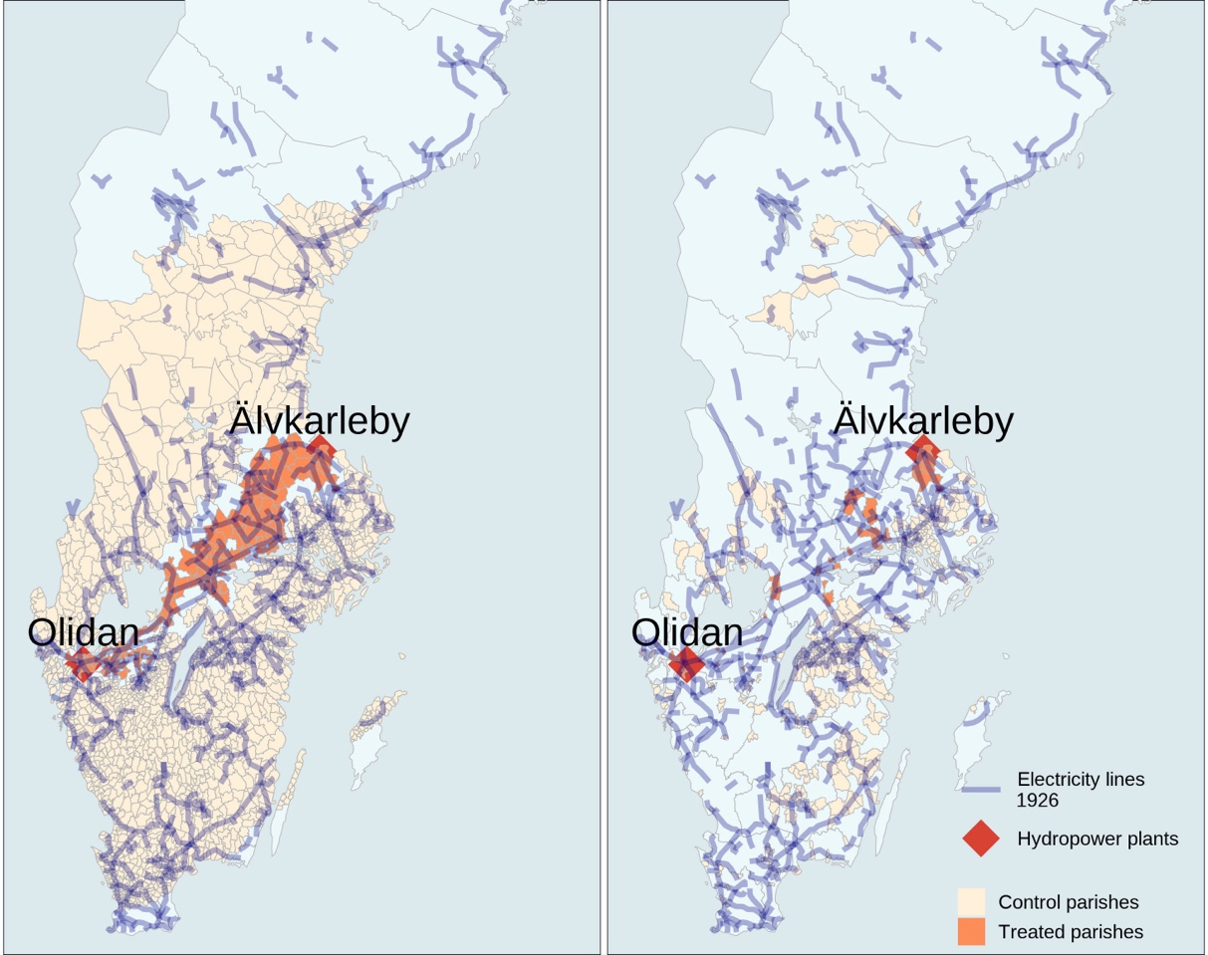
Figure 1: Map of the Western Line connecting hydrop power plants in Sweden, observed parishes in 1930 census, right
By examining areas strategically situated along this line, we can pinpoint regions that gained access to stable and reliable electricity, providing them with an advantage over other, comparable areas. Between 1915 and the completion of the Western Line in 1921, the share of electrified rural households increased rapidly, reaching over 40 percent by 1930, as shown in Figure 2. Subsequently, in the post-war era, electrification expanded rapidly, eventually reaching nearly the entire population.
Concurrently, there was an inflection in the income distribution, with the share of income going to the top 10 percent falling fast, and individuals between the 50th and 90th percentiles of the income distribution becoming better off, as shown in Figure 2. The Swedish electrification experience provides a unique setting to study the impact of new technology as an equalizing force. We examine individual outcomes in the labour market, as well as the role of institutions such as education and local union presence in shaping these outcomes (Bengtsson, 2019; Acemoglu and Johnson, 2023).
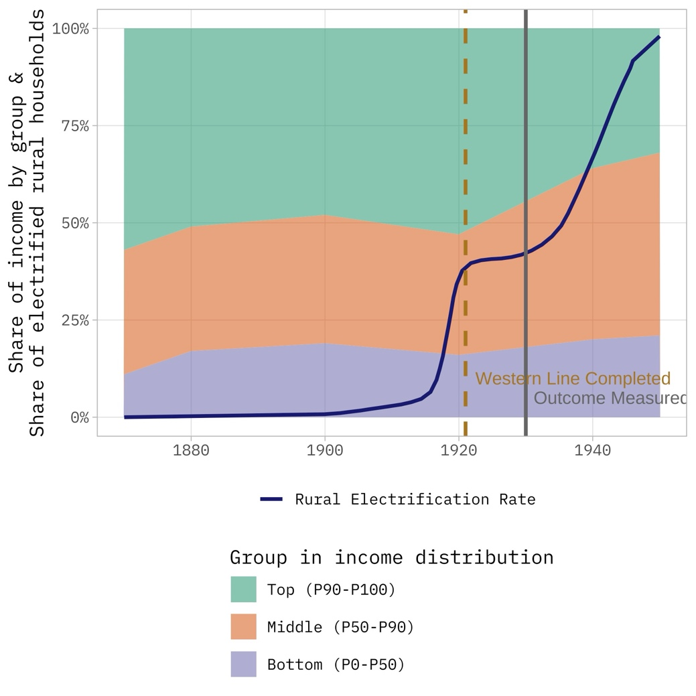
Figure 2: Evolution of income shares in Sweden and rural electrification rate

How electricity reshaped the labour market
Our findings reveal that individuals born in parishes along the main electricity grid, and thus exposed to new technology early, earned more than 30 percent higher incomes by 1930. They were also more likely to be employed in occupations augmented by electrification, both directly and indirectly.
In Figure 3, we show the three most common occupations in three job categories. It is evident that there were fewer farm workers in the parishes with early access to electrical technology, and more farmers. In jobs indirectly related to electricity, higher rates of holding these occupations were found in parishes with early access to electricity. Similarly, while the absolute rates of direct electricity job holding were low, there were more electricians, workers on generators and linesmen in early access parishes. These balanced parishes were comparable in terms of occupational structure prior to the treatment in 1890 and 1900.
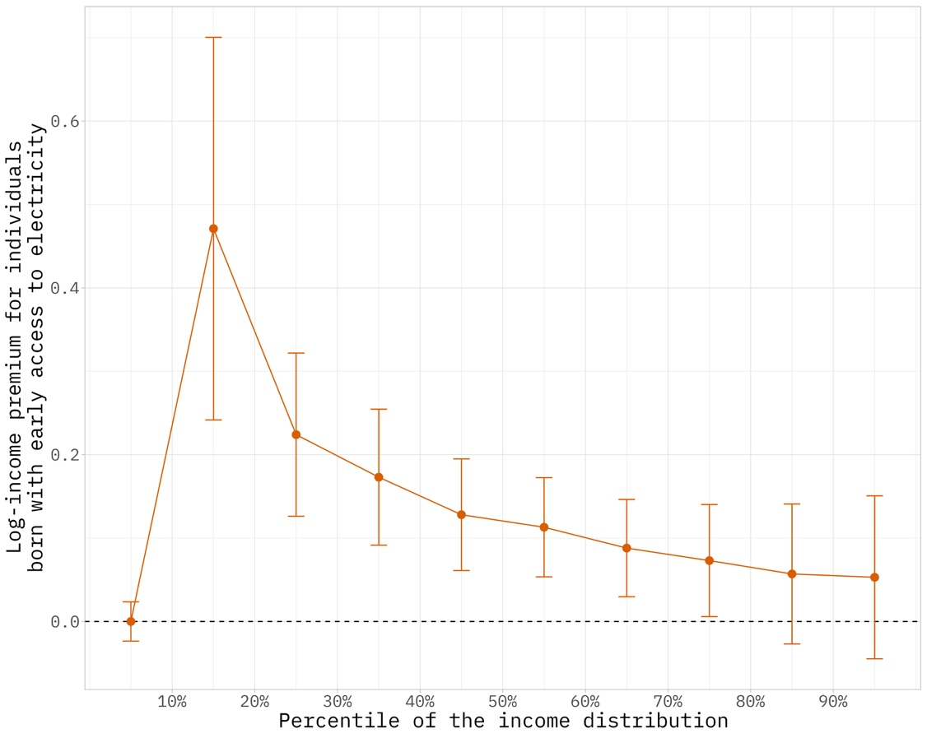
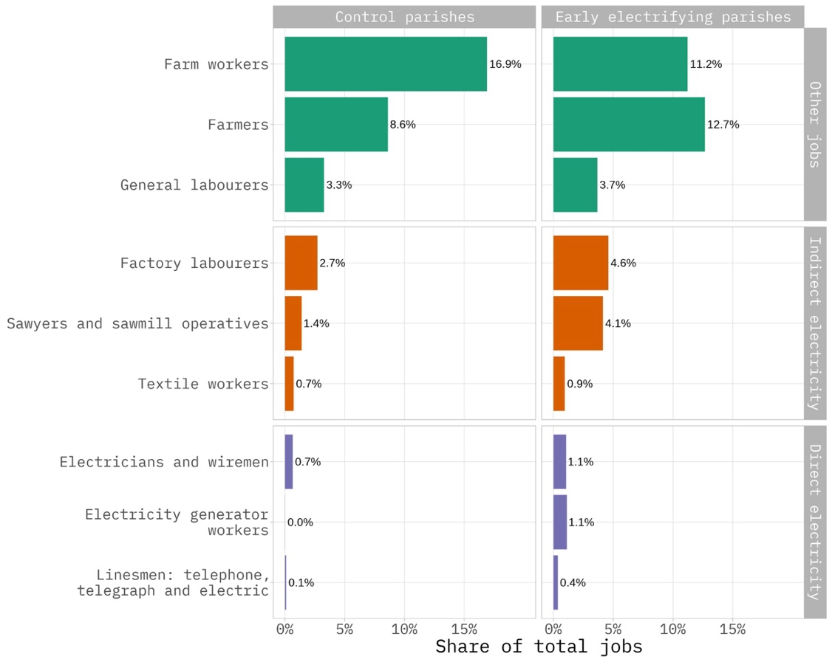
Figure 4: Share of employment in selected jobs, with birth parish type denoted by column and job type denoted by row
Figure 3: Coefficient plot for quantile regression, showing log-income premium for individuals
Our findings suggest that electrification replaced mainly unskilled occupations in agriculture while creating new positions that were filled by people with no more than primary education.
Examining impacts across the income distribution, we find that gains were concentrated in the lower end of the spectrum, with the most pronounced effects among those with only primary education. We show that early access to electricity resulted in a large income premium for those at the bottom on the income distribution in 1930, after controlling for observables such as age, gender, schooling, marital status and class of occupation. Figure 4 displays the coefficient on being born in a parish that lay along the Western Line in quantile regression.

Implications for contemporary debates
Our findings from early 20th century Sweden have implications for current discussions on technology, labour, and inequality. Our study suggests that the impact of technological change on labour markets depends crucially on the features of the technology itself. Electrification in Sweden led to the creation of new jobs accessible to workers with primary education, contributing to reduced inequality and inclusive growth. Early findings on AI suggest that the technology that provides a catch-up effect. It is a boon to novices and those workers in the bottom half of the skill distribution. However, as our understanding of this technology improves, policy makers should pay close attention to the kinds of new jobs that are created. We may yet need expanded social safety nets. Moreover, our findings underscore the importance of investing in high-quality basic education and skills development to ensure that workers can adapt to and benefit from technological change (Goldin and Katz, 2008).

References
Acemoglu, D. and Johnson, S., 2023. Power and Progress: Our Thousand-Year Struggle Over Technology and Prosperity. PublicAffairs.
Acemoglu, D. and Restrepo, P. (2019) 'Automation and New Tasks: How Technology Displaces and Reinstates Labor', Journal of Economic Perspectives, 33(2), pp. 3-30. Available at: https://doi.org/10.1257/jep.33.2.3
Acemoglu, D. and Restrepo, P. (2020) 'Robots and Jobs: Evidence from US Labor Markets', Journal of Political Economy, vol. 128, no. 6. Available at: https://doi.org/10.1086/705716
Alexopoulos, M. and Cohen, J., 2016. The medium is the measure: Technical change and employment, 1909—1949. Review of Economics and Statistics, 98(4), pp.792-810.
Autor, D. (2024) 'AI Could Actually Help Rebuild The Middle Class', Noema Magazine, 12 February. Available at: https://www.noemamag.com/how-ai-could-help-rebuild-the-middle-class/
Autor, D.H., Dorn, D. and Hanson, G.H., 2015. Untangling trade and technology: Evidence from local labour markets. The Economic Journal, 125(584), pp.621-646.
Autor, D. and Reynolds, E., 2020. The Nature of Work after the COVID Crisis: Too Few Low-Wage Jobs. The Hamilton Project • Brookings. Essay 2020-14. Available at: https://www.hamiltonproject.org/.
Bengtsson, E., 2019. The Swedish Sonderweg in question: Democratization and inequality in comparative perspective, c. 1750--1920. Past & Present, 244(1), pp.123-161.
Brynjolfsson, E., Li, D. and Raymond, L.R. (2023) 'Generative AI at Work', National Bureau of Economic Research, Working Paper No. 31161, April. Available at: https://www.nber.org/papers/w31161
Ernst, E., Merola, R. and Samaan, D. (2019) 'Economics of Artificial Intelligence: Implications for the Future of Work', IZA Journal of Labor Policy, 9(1). Available at: https://doi.org/10.2478/izajolp-2019-0004
Frey, C.B., 2019. The Technology Trap: Capital, Labor, and Power in the Age of Automation. Princeton University Press.
Goldin, C.D. and Katz, L.F., 2008. The Race Between Education and Technology. Belknap, Cambridge, MA.
Jayes, J., Molinder, J. and Enflo, K., 2024. DP18973 Power for progress: The impact of electricity on individual labor market outcomes. CEPR Discussion Paper No. 18973. CEPR Press, Paris & London. Available at: https://cepr.org/publications/dp18973.
Noy, S. and Zhang, W. (2023) 'Experimental evidence on the productivity effects of generative artificial intelligence', Science, 381, pp. 187-192. Available at: https://doi.org/10.1126/science.adh2586

